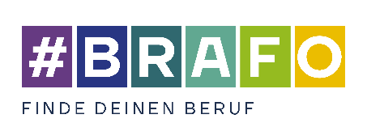
Form for the individual consultation on the
fourth structural element

Full name of pupil:
School name: |  |  | Year group:

Questions and topics | Answers and comments
Questions on the Check-U skills assessment
- Could you complete all the Check-U tests? (Skills, social skills, interests and/or professional preferences)
- Which did you not complete and why?
- What stands out to you in the test results?
- Did you learn anything new about yourself through Check-U?
- Which careers were recommended to you? Are there any other careers you would be interested in?
Knowledge
- Which of the suggested careers are you familiar with? Which are you not familiar with?
- Which careers would you like to find out more about?
- Which of the careers could you imagine working in and why?
- Are there aspects of the suggested careers that you would not be happy with?
- Are there aspects of the suggested careers that seem overly challenging to you?
- Which school subjects are most important for these careers?
- Which school subjects would you need to try harder in to be able to train for these careers?

Networks/peers
- What do your parents and friends think about these job profiles?
- What would their reaction be if you told them you were going to pursue one of these careers?
Next steps
- How confident do you feel about your career aspirations?
- Do you have any questions about the careers mentioned?
- Which steps will take you closer to your chosen career/training path? (E.g. conducting your own research, asking for career advice)
- Do you know of any additional career guidance opportunities at your school or outside of school? If yes, please provide details. Which of these opportunities would you be interested in?
- Do you already know where you would like to complete your next internship?

