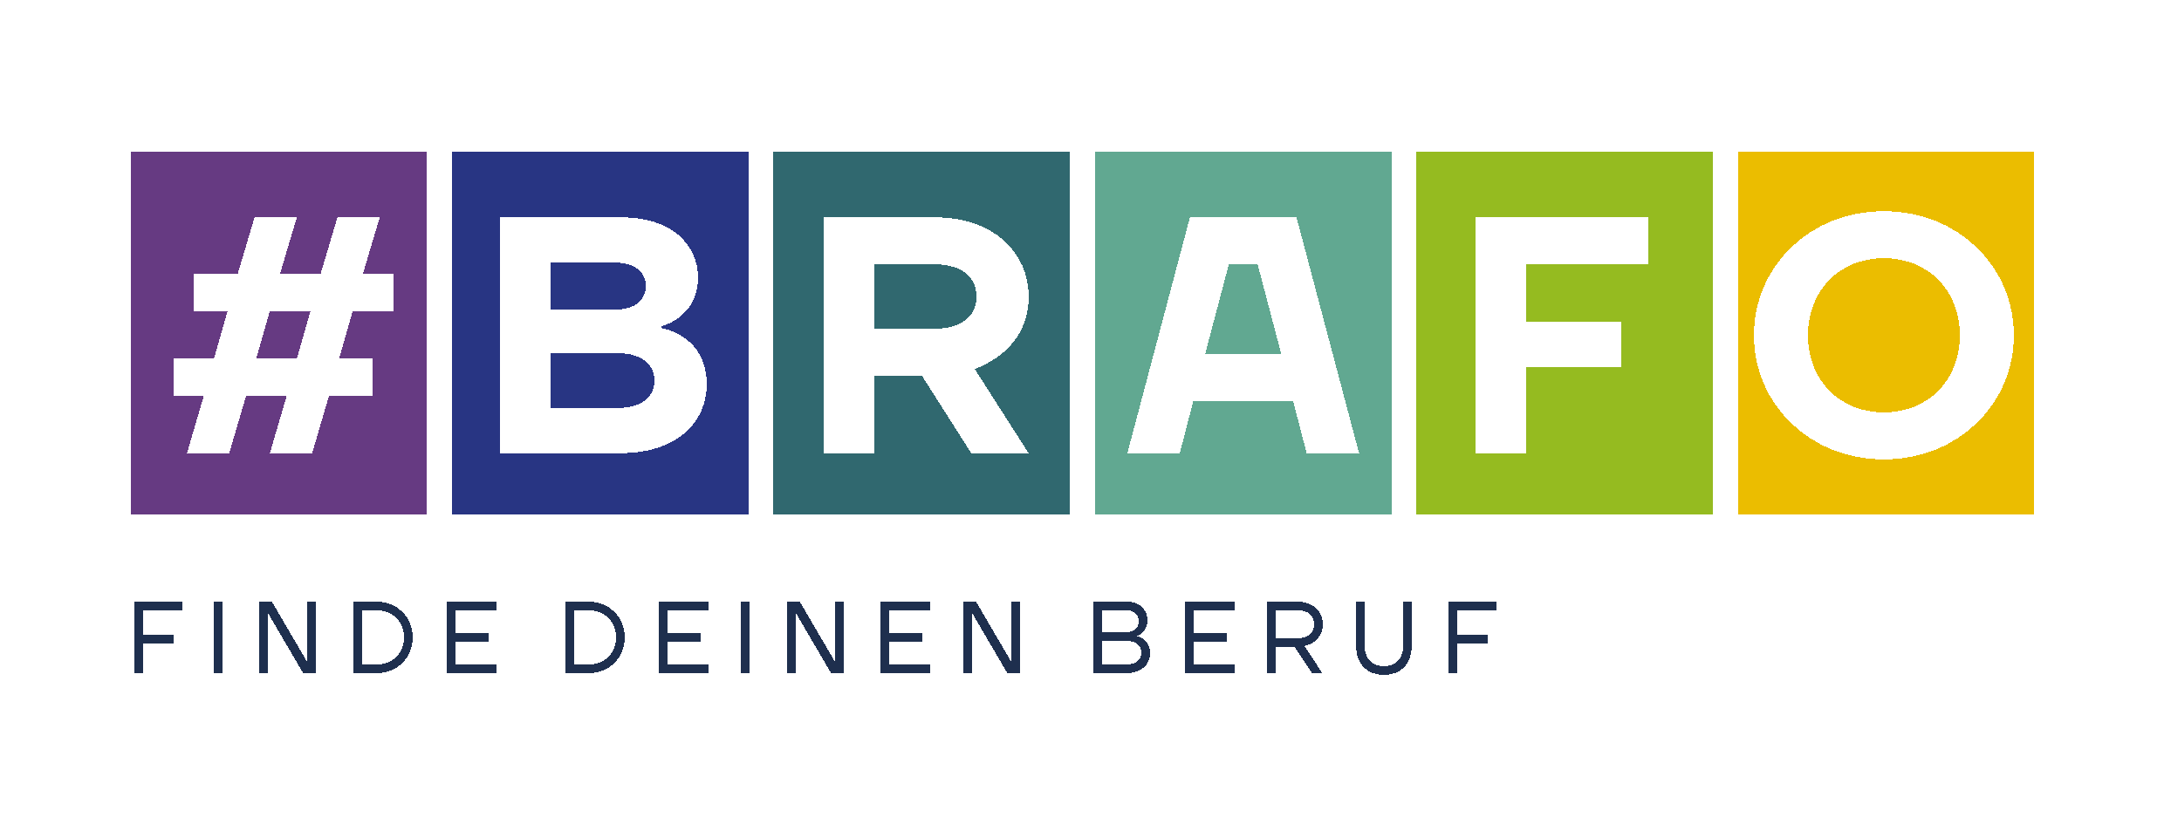

Finde Deinen Beruf: Find Your Career

BRAFO: Approaching the correct career path early on

**Landesprogramm zur Berufsorientierung in Sachsen-Anhalt**

**BRAFO** – **B**erufswahl **R**ichtig **A**ngehen **F**rühzeitig **O**rientieren

**Guide to Action for**

**Students and Parents**

Imprint

Version from: February 2022

Published by:

Ministry for Work, Social Issues, Health, and Equalization of the state Saxony-Anhalt

Turmschanzenstraße 25

39114 Magdeburg

[www.brafo.sachsen-anhalt.de](http://www.brafo.sachsen-anhalt.de)

in cooperation with the regional office Saxony-Anhalt-Thüringia, the Federal Employment Agency, and the Ministry of Education of the state Saxony-Anhalt.

Written by:

Forschungsinstitut Betriebliche Bildung (f-bb) gGmbH

Rollnerstraße 14

90408 Nürnberg

[www.f-bb.de](http://www.f-bb.de)



Please send any notes or suggestions for changes and additions to the following guide to action to:

[info-brafo@f-bb.de](mailto:info-brafo@f-bb.de)

This publication is open to downloading at <https://lsaurl.de/brafoservice>



The state-wide career orientation program „BRAFO – Berufswahl Richtig Angehen Frühzeitig Orientieren“ is financed by by: The European Union of the state Saxony-Anhalt, the Employment Agency, and the Federal Ministry für Education and Research.

**Table of Contents**

Forword 7

1 Parents support BRAFO 10

1.1 Roles and Responsibilites 10

1.2 Networking in BRAFO 11

1.3 The Career-Choice Passport 12

2 What is BRAFO? 14

2.1 With what does BRAFO help? 14

2.2 What is the process with BRAFO ? 15

3 Asset preview 32

Forword

Dear students,

dear parents and caretakers,

starting a career is a big challenge especially because choosing between the 600 different types of apprenticeships makes identifying the correct option for yourself difficult.

A careful career orientation can, and should help you, dear students, with the transition from school to a career. This is what the career orientation program „**BRAFO** – **B**erufswahl **R**ichtig **A**ngehen **F**rühzeitig **O**rientieren“ of the Ministry for Work, Social Issues, Health, and Equalization of Saxony-Anhalt, the Ministry of Education of the state Saxony-Anhalt, and the Regional Office of Saxony-Anhalt-Thüringia’s Employment Agency. For this, the program plans five steps that build upon each other. The path begins in the seventh grade and leads to the career consultation provided by the Employment Agency.

Dear students, within the program BRAFO, you can try out different areas of work and gather insight into different occupational fields. This way, you can closely experience different operational processes in companies. Why not join an electrician during a technical inspection of an automatic high-bay warehouse via tablet? Or experience a day together with a geriatric nurse and their nursing robot working in a nursing home?

This guide to action gives a small insight into the BRAFO program with its five steps – Interest and company exploration, workshop days, factory internships, and the exploration tool Check-U.

Dear parents and caretakers, beyond this, you will find suggestions and examples on how you can support your child in the BRAFO process. The guide describes your role in the process of the career orientation. It shows you what is important while working in cooperation with the school, companies, and/or the BRAFO institution.

For a successful joint career orientation, we wish you good luck and success!

|  |  |  |
| --- | --- | --- |
| Petra Grimm-Benne  Minister for Work, Social Issues, Health, and Equality of the State Saxony-Anhalt | Eva Feußner  Minister of Education of the State Saxony-Anhalt | Markus Behrens  Chairman of Business Management of the regional office Saxony-Anhalt-Thuringia of the State Employment Agency |

Magdeburg, in February 2022

Note about the guide:

The colored bars in the margins indicate which pages of the guide are important

for you students,

for you parents and/or caretaker, and

for both.

This way, you will get an idea for what happens in the individual steps and who will accompany you.

At the end of this guide, you can find a summary of important documents that will be used during the BRAFO program.

**Chapter 1**

**Parents Supporting BRAFO**

1. Parents Supporting BRAFO

Dear parents and caretakers, you play an important role in your child’s career orientation. Especially you can have a positive influence in their interest, motivation, self-esteem, and perseverance during the orientational process. Often, your opinion is valued, and your suggestions carry more weight than those of friends and acquaintances.

BRAFO follows the basic idea, that all those involved in the process for career orientation should be actively included. Therefore, you are sincerely invited to involve yourself through parent-teacher conferences and other parent-events. Support and accompany your child in their career orientation. Bring up your own experiences with choosing a career and your day-to-day work life in conversations with the school and the BRAFO educational institution.

1.1 Roles and Responsibilities

In your accompanying role you can help by

✓ motivating your child,

✓ encouraging their interests and plans,

✓ encouraging them to experiment and explore careers without prejudice, and

✓ helping in the search for internship and/or apprenticeship spots.

No career should be excluded just because it is seen as a **woman’s or man’s job**. Early on, speak clearly with your child following the motto: “There are a large variety of possible careers.” Show interest in their ideas and thoughts regarding possible careers. Actively listening, when your child talks about their experiences during the career orientation, is just as important as fielding questions about your own career path.

First, the following guide explains the five BRAFO steps. Each step includes a task, riddle and/or quiz. This way, you can help your child as well es encourage their curiosity. Together with you child, read the individual chapters and complete the tasks and riddles.

## 1.2 Networking in BRAFO

As parents and caretakers, you have collected your own experiences in the job market and working life. Why not include these experiences in the process of helping your child choose a career?

The more your child learns about a career, the better they can make a choice. Why not integrate the current family and professional networks? Engage your child in conversations with relatives or acquaintances about what is involved in their work. Maybe they can also help in the search for a fitting spot for internships that are part of the third and fifth steps of the BRAFO procedure.

A good collaboration within the BRAFO career path orientational program between the school, the BRAFO educational institution, the companies, and the Employment Agency’s career orientation consultant is defined through

* exchanging and gathering information,
* collectively doing everything to strengthen your child’s motivation and self-esteem during the career orientation,
* and you discussing your child’s experiences together.

## The Career-Choice Passport

In the career-choice passport, all the experiences and results, from the orientational process, including the five BRAFO-steps, are documented. This way you, your child, the teachers, and the professionals of the BRAFO educational institution, can follow up on what your child has done so far and which interests and strengths they have shown.

Support your child in carefully filling out the career-choice passport and completing all included the certificates and documents.

Your child will receive their career-choice passport from the BRAFO institution in the seventh grade. When they receive the document, it will also be explained.

**You may find more information about the career-choice passport here:**



**Chapter 2**

**What is BRAFO?**

2. What is BRAFO?

BRAFO is the state-wide career orientation program in Saxony-Anhalt. It stands for: **B**erufswahl **R**ichtig **A**ngehen **F**rühzeitig **O**rientieren (Approaching the correct career path early on) and is designed for all students from the seventh grade and up. BRAFO has five steps wherein theory (CHECK) and action phases (ACTION) will alternate.

If you and your parents want to learn more about BRAFO, you can find an explanatory video and further information under [www.brafo.sachsen-anhalt.de](https://ms.sachsen-anhalt.de/themen/arbeit/berufsorientierung-ausbildung/brafo-das-landesberufsbildungsprogramm/).

**For the explanatory video:**



## 2.1 With what does BRAFO help?

BRAFO supports you in discovering,

* what interests you,
* what you’re good at,
* which tasks you enjoy, and
* which careers are right for you.

BRAFO gives you the possibility to try out different tasks and professional activities. Your teachers and the professionals from the BRAFO educational institution will help you to explore your interests and strengths. BRAFO wants to encourage you to reflect your experiences and to speak about them with you parents and/or caretakers. Talk to them, tell them about all the things you have experienced during the BRAFO steps, what you enjoyed, and what career fields you want to try yourself with.2.2 How does BRAFO work?

BRAFO works in five steps.

**You are here.**



|  |  |  |  |  |
| --- | --- | --- | --- | --- |
| **Step 1:**  **Explore Interests and Skills**  **(CHECK)** | **Step 2:**  **Company Exploration or Workshops**  **(ACTION)** | **Step 3:**  **First Internship**  **(ACTION)** | **Step 4:**  **Defining Skills**  **(CHECK)** | **Step 5:**  **Second Internship**  **(ACTION)** |

|  |
| --- |
| **Step 1: Exploring Interests and Skills (CHECK)** |

You take the first step of career orientation in the seventh grade: Exploring Interests and Skills. In six days you will gain a rough idea of the variety found in the professional world.



Day 1

On the first day, the BRAFO educational institution will explain the details of the program. You will be introduced to the four living environments and twelve fields of activity (TF), which you can try out and experience in the following days. You probably know, that within each of the different fields of activity there are many different exciting jobs to be found, right? You can find all of the different living environments and fields of activity included in BRAFO in the following chart or at the BRAFO-website [www.brafo.sachsen-anhalt.de](https://ms.sachsen-anhalt.de/themen/arbeit/berufsorientierung-ausbildung/brafo-das-landesberufsbildungsprogramm/).

Look at the chart with your parents or caretaker. Ask them in case you don’t understand any of the words or don’t understand which type of work is meant.

|  |  |  |
| --- | --- | --- |
|  | **Nature, and Technology:** | |
| TF1: | producing, processing, fixing, and handling machinery |
| TF2: | planting plants, breeding animals |
| TF3: | recycling, collecting raw materials, disposal, cleaning |
|  | **Man, and the Community** | |
| TF4: | helping people, nursing, medical/cosmetic treatments |
| TF5: | raising, qualifying, and teaching |
| TF6: | saving, protecting, guiding traffic |
|  | **Man, and Culture** | |
| TF7: | advertising, convincing people about ideas and products |
| TF8: | serving, homing, and preparing meals |
| TF9: | being artsy, writing, and entertaining |
|  | **Man, and Information/Knowledge** | |
| TF10: | processing data, consulting, and informing |
| TF11: | buying/selling, working at a cash register, packing, filling |
| TF12: | measuring, checking, trying, and controlling |

Imagine 1: Living environments and fields of activity

**Here you can find the first step on the BRAFO website:**



The separation into living environments and fields of activity helps you to learn about a larger variety of careers. At the end of the first day, you will decide on one field of activity per living environment.

**IMPORTANT: In the first step of BRAFO you will not be introduced to any specific careers. This does not begin until the next steps.**

Day 2 through 5

Which living environment fits me? What do I choose? Surely you thought about what you enjoy doing in your free time: Crafting, playing on the computer, baking, fixing bikes, or just being outside. In the BRAFO institution’s workshops, you explore the field of activity that you chose on the first day. You receive an exciting insight and complete a small keepsake that you can show your parents.

Day 6

The skills assessment happens on the sixth day. This complicated term an describes an exciting question-answer game on the computer. In it, you will assess your own skills and interests: “I am good at…”, “I would rather do…”. After the skills assessment the results will be collected and evaluated. The professional from the BRAFO educational institution will look at the results and, together, you will decide what you want to do in the second step. Here there is a choice between exploring a company or a workshop. Talk to your parents about this.



Dear parents, please support your child without prejudice regarding their interests and strengths. Within each field of activity there are many areas. For example, discuss your child’s experiences during the individual days in this first couple of steps. What was especially fun and why? What didn’t you like and for what reason?

In the skills assessment there are no results that are “good” or “bad.” Based on their own interests, your child will choose what they would like to try out and what they are already good at. Speak to the professionals of the BRAFO educational institution for advice regarding the next BRAFO-step.

You discuss the results of the skills assessment and your experiences and interests. After that, you will get a recommendation for the second BRAFO step— Participating in a workshop or exploring a company.

Task 1

During the first step of your BRAFO-Days, you can get to know and try out many things. I have written down all the things you can do.

Oh no, I was too fast. Some letters fell. Can you put them back into the correct spots? Let your parents help you.



**fe en**

**am om ter ar iten**

**mes n**

**b c en**

**s gen**

**fr sie n**

**k chen**

**be**

**C**

**pu**

**re**

**i**

**se**

**a**

**k**

**il**

**o**

**ä**

Sägen – sawing

Backen – baking

Feilen – filing

Messen – measuring

Frisieren – hair styling

Am computer arbeiten – working at the computer

Kochen - cooking

|  |
| --- |
| **Step 2: Company Exploration or Workshops (ACTION)** |

**You are here.**



|  |  |  |  |  |
| --- | --- | --- | --- | --- |
| **Step 1:**  **Explore Interests and Skills**  **(CHECK)** | **Step 2:**  **Company Exploration or Workshops**  **(ACTION)** | **Step 3:**  **First Internship**  **(ACTION)** | **Step 4:**  **Defining Skills**  **(CHECK)** | **Step 5:**  **Second Internship**  **(ACTION)** |

In the second step you will begin by either exploring a company or participating in workshops. Both will last five day and take place during the eighth grade.

Company Exploration

You’re already pretty sure what you like and what type of job you enjoy? Then you should participate by exploring a company. Where and in which company? Together with the professionals of the BRAFO educational institution you and your parents will choose a company that fits into your chosen living environment. In the five days there, you will learn more about the different tasks that come up in the day-to-day. You will explore all the different areas of the company and get a good idea of what it involves. The companies can be separated into production and service companies. The first, produces items, such as tables or bread. The second performs services, such as cleaning clothing or fixing cars.

To prepare, you can ask your parents or caretaker, how it is at their work. For example, how do the different areas of the company work together?

Workshops

You’re not sure yet what you like? What type of work you enjoy? Then you should participate in a workshop by the BRAFO institution. Building up on the result from the first BRAFO step, you choose an occupational field, that you will explore more during the workshops. During this, you will receive a more comprehensive view of the typical jobs and routines of a company in your chosen field.

The exploration of a company and the workshops end in a conversation:

With the professionals from the BRAFO institution, you will discuss the experiences you had and how these fit with your experiences from the first step in BRAFO. Together, during this conversation, you will decide on the next steps, especially the upcoming internship.



Dear parents, let your child describe their experiences and insights from exploring a company or workshops to you. What did they enjoy? Where would your child like to complete their internship?

Task 2

In the second step you can see, through the company exploration or workshops, which departments in the company are involved in, for example, developing toys.

I was there once. First, a plan was made, then packaging and double checking… or was it first packaged and then built? I guess I got that confused. Do you know the right order? Your parents can probably help you!



writing receipts

double-check

storage

production

|  |
| --- |
| **Step 3: First Internship (ACTION)** |

|  |  |  |  |  |
| --- | --- | --- | --- | --- |
|  |  |  |  |  |

**You are here.**



|  |  |  |  |  |
| --- | --- | --- | --- | --- |
| **Step 1:**  **Explore Interests and Skills**  **(CHECK)** | **Step 2:**  **Company Exploration or Workshops**  **(ACTION)** | **Step 3:**  **First Internship**  **(ACTION)** | **Step 4:**  **Defining Skills**  **(CHECK)** | **Step 5:**  **Second Internship**  **(ACTION)** |

Finally, it’s time: During the third BRAFO step you have the chance to try yourself out during an internship. During this, think about the first two BRAFO steps. What are you good at? What did you enjoy? Choose a corresponding internship. Surely, your parents, and even your teachers, will help you in your search for one.

To prepare, you and your parents or caretaker can use the German Federal Working Group’s SCHULEWIRTSCHAFT (school economics) and the Federal Employment Agency’s checklist.

**You can find the checklist here:**



The internship will take ten days und will take place in a company or business. During this time, you will gain more detailed view into the realities of the work apprenticeships daily life as well as getting to know operational processes.

After the internship you have the chance to evaluate this with the teachers. For this, keep an eye on your strengths and skills. During the evaluation, you will work out together which school subjects are most important for your career-path.

Describe your experiences and insights to your parents and friends. Ask them, which experiences did they have during their internship.

Dear parents, have your kids describe their experiences and insights into their first internship. What did your child have a chance to see? What did they enjoy? What would your child like to learn more about?

Task 3

Which careers are available in the company where the internship took place? Which did you enjoy the most and why? What do you need to have (requirements, skills)?

More nformation can be found at BERUFENET.

**To find the BERUFENET:**



|  |
| --- |
| **Step 4: Defining Skills, Check-U (CHECK)** |

|  |  |  |  |  |
| --- | --- | --- | --- | --- |
|  |  |  |  |  |

**Du bist jetzt hier.**



|  |  |  |  |  |
| --- | --- | --- | --- | --- |
| **Step 1:**  **Explore Interests and Skills**  **(CHECK)** | **Step 2:**  **Company Exploration or Workshops**  **(ACTION)** | **Step 3:**  **First Internship**  **(ACTION)** | **Step 4:**  **Defining Skills**  **(CHECK)** | **Step 5:**  **Second Internship**  **(ACTION)** |

Everything that you experienced in BRAFO, will be turned head over heels? Not exactly. You are in the 9th grade – time for the fourth BRAFO step. Here, all the things that you have experienced, will be summed up and sorted.

First you have a conversation with the professional from the BRAFO institution about

* all the past steps in BRAFO,
* your collective experiences,
* your interests and inclinations,
* your strengths and skills,
* your professional expectations.

Beyond that the exploratory tool [Check-U](https://www.arbeitsagentur.de/bildung/welche-ausbildung-welches-studium-passt) will be introduced, which you can then try out.

**Here you can find Check-U:**



In Check-U you answer questions at the computer. In the end you will receive not only your assessment about the direction your technical and social competencies lie, which interests and professional preferences you have, but also suggestions to for you fitting apprenticeships.

Check-U helps you to answer the following questions: 

* What am I good at?
* What fits to my strengths?
* What type of contents am I interested in?
* What is important for my professional future?



After Check-U you will have another conversation with the professional from the BRAFO institution. During it, you will talk about your strengths and about careers that could interest you. The goal of the conversation Is that you learn a lot about the fitting careers and can think about your next steps.

After this step you will decide in which company you want to complete your second internship. You can talk about your thoughts with your parents, caretakers, and/or teachers. If you would like, your career consultant at the Employment Agency will also help you.

Task 4

Dear Guardians, have your child tell you about their discoveries through the exploratory tools. What did they enjoy? What talents and skills can they take with them into the next BRAFO step, the second internship. Where would your child like to complete their internship?

During BRAFO, every now and then, you should think about which strengths and interests you have.

At first, I didn’t really know what to think about it. So, I asked my parents different questions and about their past week. Why don’t you ask your parents and see if these questions bring new ideas!

What did you experience?

What did you learn?

What would you have liked to be different?

Where could you apply your strengths?

What did you enjoy?



|  |
| --- |
| **Step 5: Second Internship (ACTION)** |

Now you have arrived in the last step of BRAFO: The second internship.

**You are here.**



|  |  |  |  |  |
| --- | --- | --- | --- | --- |
| **Step 1:**  **Explore Interests and Skills**  **(CHECK)** | **Step 2:**  **Company Exploration or Workshops**  **(ACTION)** | **Step 3:**  **First Internship**  **(ACTION)** | **Step 4:**  **Defining Skills**  **(CHECK)** | **Step 5:**  **Second Internship**  **(ACTION)** |

It’s exciting, all the things you can experience in the BRAFO process. You have tried out different fields of activities. You probably enjoyed some more than others. You checked out one or other companies and got to know company procedures. The last BRAFO step provides the opportunity to take a closer look at jobs or apprenticeships that seemed interesting so far and to see if they match you.

With your parents and carefully for the internship, that is supposed to happen in the 9th grade. For this, use the documents that you collected in the career-choice passport. With help from your teachers as well es your caretakers, you will find a fitting internship. Sometimes, friends or siblings also have tips where you may find interesting internships hidden in the region.

The internship lasts ten days and takes place at a company. Use this time to expand your impressions and experiences in the real working and apprenticeship world. Ask your internship overseer questions about specific apprenticeship contents and about company procedures and processes.



After the internship you have the chance, in a conversation with your teacher or with your parents, to reflect upon the internship. For this, refer to the experiences from all the BRAFO steps. Beyond that, accept the offer of a conversation with the career consultant from the Employment Agency. They will help you with your future career path plans.

Dear parents, the second internship marks the end of the BRAFO program. Afterwards, continue to guide your child during the process of choosing a career and applying for jobs during the transition from school to work. Together, use the offer from the consultant at the Employment Agency to help find and choose a fitting apprenticeship placement.

Task 5

BRAFO is now nearly over and I finally, I will apply for apprenticeship positions.

That’s why I will put together my application packet and pack: a shopping list, a couple of pens, a playlist with my favorite songs … what? How? What does not belong?

Can you and your parents help me to complete my packet?



Aufgabe 6

In the end: Which questions are still open for you? About what would you like to talk to your career consultant?

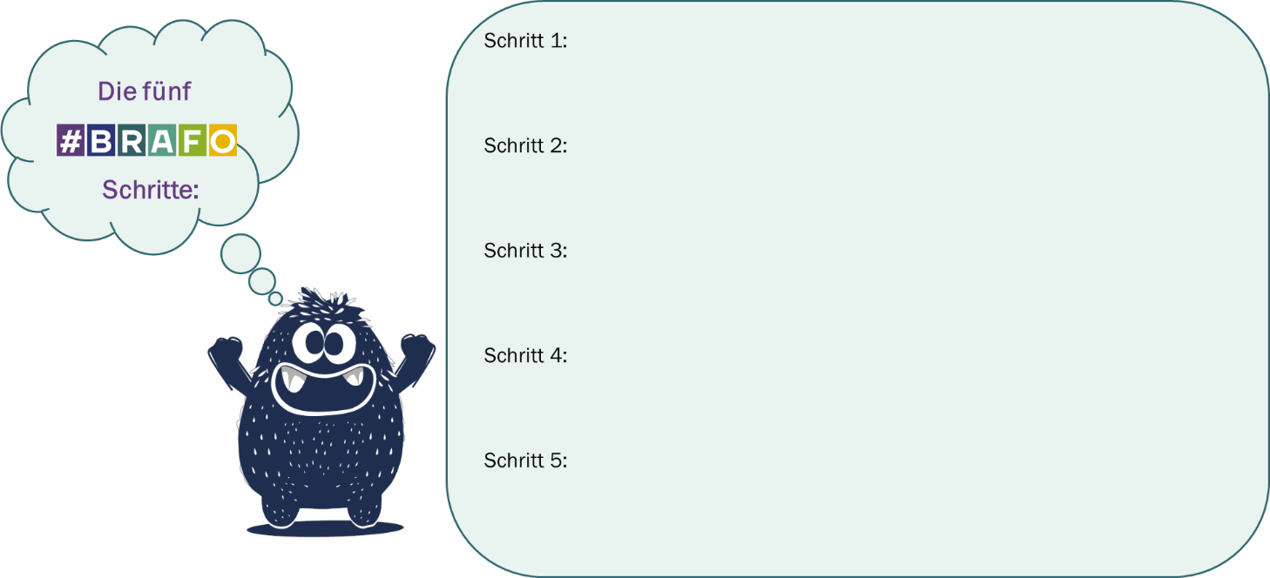

Question 1:

________________________________________________________________________

________________________________________________________________________

________________________________________________________________________

Question 2:

________________________________________________________________________

________________________________________________________________________

________________________________________________________________________

Question 3:

________________________________________________________________________

________________________________________________________________________

________________________________________________________________________

Question 4:

________________________________________________________________________

________________________________________________________________________

________________________________________________________________________

Question 5:

________________________________________________________________________

________________________________________________________________________

________________________________________________________________________

Attachment preview

This chapter offers an overview over the materials that will be used in BRAFO.

You will receive the material from the BRAFO institution and/or the school. Your child will receive the BRAFO participation certification at the different BRAFO steps.

More information can be found on the BRAFO website: [www.brafo.sachsen-anhalt.de](https://ms.sachsen-anhalt.de/themen/arbeit/berufsorientierung-ausbildung/brafo-das-landesberufsbildungsprogramm/).

**Here you can find the website:**



|  |  |
| --- | --- |
|  |  |
| Internship contract, for example for a exploring a company |  |

|  |  |
| --- | --- |
| Report in the second BRAFO step, for example for exploring a company |  |
| Participation certificate for each step, for example, for exploring a company |  |

Your own notes

Your own notes